Week 7 Final Report
SiteChat for CleanTasker · ICT942 Industry Project Report, Assessment 2
Amrit (Project Manager), Madhab, Sujit, Subham
Epic window: 31 Aug 2026 – 6 Sept 2026
Table of Contents
Executive Summary 1
1. Landscape Analysis 2
1.1 Technology & Market Survey 2
1.2 Gap Analysis (As-Is → To-Be) 3
2. Solution Design 4
2.1 Architecture — C4 System Context 4
2.2 Architecture — C4 Container Diagram 5
2.3 Data Flow Narrative 5
2.4 Technology Stack Justification (Individual Evidence) 6
3. Cost Model 6
3.1 CAPEX (Year 1) 7
3.2 OPEX (Monthly, MVP scale) 7
3.3 Cost-Benefit and ROI 7
4. PoC Kick-off 8
5. Meeting Minutes Summary 8
6. Risk Register Summary 9
7. Conclusion & Next Steps 9

Executive Summary
Week 7 covered three linked strands of work for the SiteChat project: a landscape analysis of real-time communication platforms and the operational gaps they address, a solution design translating those findings into an architecture and technology stack, a cost model validating the design’s financial viability, and the PoC kick-off that hands the design over to Week 8’s build sprint. All six board tasks (Technology & Market Survey, Gap Analysis, Architecture Diagram, Tech Stack Justification, Cost Model, PoC Kick-off) were completed and pushed to GitHub across the week, with the repository tagged v0.7-week7 on 6 September.
The team’s central recommendation — carried through every subsequent deliverable — is to build SiteChat on Firebase (Firestore, Auth, Cloud Messaging, Cloud Functions, Hosting), on the basis that it uniquely combines offline-first data sync, native push notifications, and integrated authentication in a single SDK set the team already has working familiarity with. This choice is stress-tested against three alternatives (Supabase, Pusher, Ably) in Section 1, carried into a C4-style architecture in Section 2, individually justified against alternatives in Section 3, and shown to break even on cost within the first month of operation in Section 4.

1. Landscape Analysis

1.1 Technology & Market Survey
Four candidate real-time platforms were evaluated against the requirements of a site-based chat and notification tool: low-latency delivery, Flutter/React SDK support, offline sync, native push integration, authentication, and cost at MVP scale (~150 users across 10 sites).
Tools evaluated: Firebase (Firestore + Cloud Messaging), Supabase Realtime, Pusher Channels, and Ably.
Criteria | Firebase (Firestore + FCM) | Supabase Realtime | Pusher Channels | Ably
Real-time latency | Low (~100–300ms) | Low (~100–300ms) | Very low (<100ms) | Very low (<100ms)
Flutter/React SDK maturity | Excellent, official SDKs | Good, community Flutter SDK | Good, official SDKs | Good, official SDKs
Offline sync & caching | Built-in (Firestore offline persistence) | Limited, manual caching | None (messaging only) | Partial (history API)
Push notifications | Native (FCM) | Requires separate FCM/APNs wiring | Requires separate wiring | Requires separate wiring
Auth integration | Native (Firebase Auth) | Native (Supabase Auth) | Bring-your-own | Bring-your-own
Pricing at MVP scale | Free tier generous; Blaze pay-as-you-go | Free tier + $25/mo Pro | Free tier limited (100 conns) | Free tier limited
Team familiarity | High (already using Firebase) | Low | Low | Low
Vendor lock-in risk | Medium | Low (Postgres-based) | Medium | Medium
Site-based data querying | Strong (Firestore queries/indexes) | Strong (SQL) | None | Weak
Finding: Firebase is the only candidate that unifies persistence, offline sync, authentication, and push delivery in one SDK set. Supabase is a stronger long-term portability play but would add engineering overhead the Weeks 7–8 timeline cannot absorb; Pusher and Ably are excellent pure messaging layers but would still require a separate database and notification service bolted on.
Recommendation: Proceed with Firebase (Firestore + Cloud Messaging + Firebase Auth) as SiteChat’s core backend.

1.2 Gap Analysis (As-Is → To-Be)
As-Is: CleanTasker site communication today relies on personal phone calls, SMS, or third-party apps (e.g. WhatsApp) with no central record, no linkage to a specific site or shift, no shared visibility for management, and no offline access to prior conversations for staff working in low-signal areas.
Gap → Solution mapping:
ID | Gap Identified (As-Is) | Proposed SiteChat Solution (To-Be)
G1 | No centralised, real-time communication channel | Real-time chat rooms scoped per job site, built on Firestore
G2 | Messages not linked to a specific site/job context | Site-based channel structure with metadata (site ID, address, active shift)
G3 | No notification system for urgent updates | Push notifications via Firebase Cloud Messaging, triggered on new messages/alerts
G4 | No audit trail / message history | Persistent Firestore message store with timestamps, sender ID, read receipts
G5 | No offline access on-site | Firestore offline persistence with sync-on-reconnect
G6 | No visibility for management across sites | Manager dashboard aggregating activity across assigned sites
Scope decision: Gaps G1–G5 are in scope for the Weeks 7–8 PoC as the core value proposition. G6 (manager dashboard) is descoped to a stretch goal to protect delivery of the core chat/notification PoC within the available time.

2. Solution Design

2.1 Architecture — C4 System Context
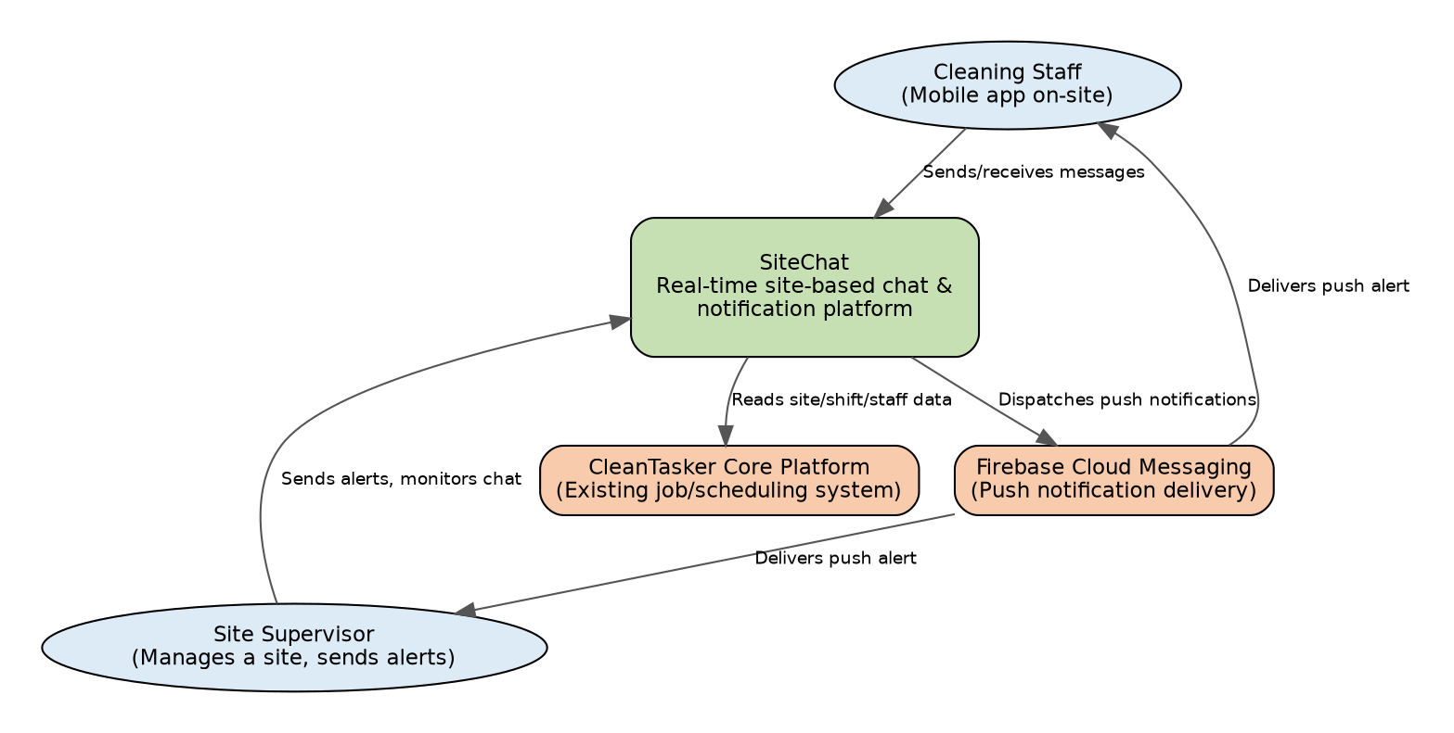
System Context Diagram
The system context establishes SiteChat’s boundary: cleaning staff and site supervisors interact with SiteChat directly, while SiteChat in turn reads job/site/shift data from the existing CleanTasker core platform and dispatches all push alerts through Firebase Cloud Messaging.

2.2 Architecture — C4 Container Diagram
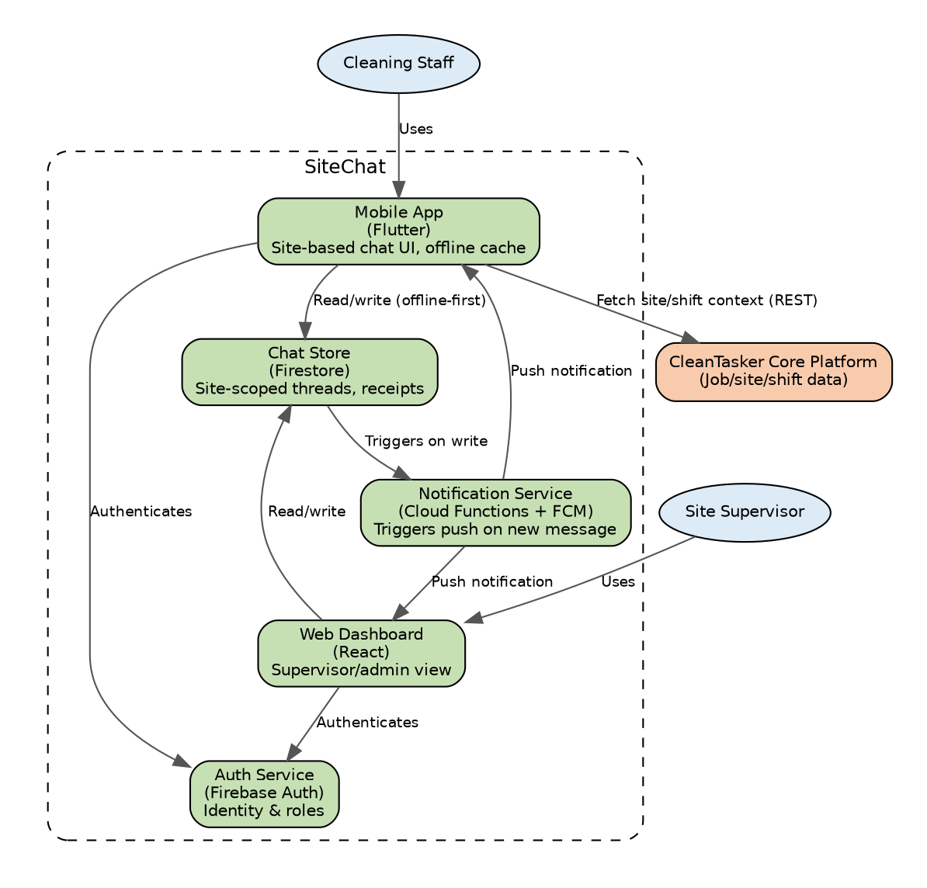
Container Diagram
Within SiteChat, the Flutter mobile app and React web dashboard both authenticate against Firebase Auth and read/write directly to a shared Firestore chat store. A Cloud Function listens for new writes and triggers push notifications via FCM to any offline or backgrounded recipient.

2.3 Data Flow Narrative
- Authentication — A worker or supervisor logs in via Firebase Auth, which issues a role-scoped session token (worker vs supervisor).
- Site context load — On login, the app fetches the user’s active site/shift assignment from CleanTasker and joins the corresponding Firestore chat collection (addresses G2).
- Message send — Messages are written directly to Firestore; offline writes are queued locally and synced on reconnect (addresses G5).
- Real-time propagation — Firestore’s realtime listeners push new messages instantly to all connected clients on that site’s thread (addresses G1).
- Notification trigger — A Cloud Function fires on new writes and dispatches an FCM push if the message is urgent or the recipient is offline (addresses G3).
- Persistence & audit — Every message is stored with sender ID, timestamp, site ID, and read-receipt status for a queryable audit trail (addresses G4).
- Supervisor oversight — The web dashboard aggregates read access across assigned sites, enforced by Firestore security rules (partial groundwork for G6).

2.4 Technology Stack Justification (Individual Evidence)
Component | Chosen Technology | Alternatives Considered | Reason for Choice
Mobile client | Flutter | React Native, native Android/iOS | Single codebase, team familiarity, strong Firebase SDK support
Web dashboard | React | Vue.js, Angular | Team familiarity; large UI component ecosystem
Real-time database | Firebase Firestore | Supabase (Postgres), MongoDB Realm | Native offline persistence + realtime listeners; integrates with Auth/FCM
Authentication | Firebase Auth | Auth0, Supabase Auth, custom JWT | Zero extra infra; integrates with Firestore security rules
Push notifications | Firebase Cloud Messaging | OneSignal, Pusher Beams | Single vendor, free at PoC scale, native Flutter plugin
Backend logic/triggers | Cloud Functions for Firebase | Custom Node/Express, AWS Lambda | Serverless, auto-scales, no server management for a 2-week PoC
Hosting (dashboard) | Firebase Hosting | Vercel, Netlify | Keeps stack under one platform/billing account
Version control/CI | GitHub + GitHub Actions (planned) | GitLab, Bitbucket | Existing team GitHub org already in use
Trade-off accepted: Consolidating on Firebase creates single-vendor dependency, accepted given the short PoC timeline, with a Supabase migration path documented as contingency (see Risk Register, R1).

3. Cost Model
Figures marked [TBC] are placeholders to be replaced with live Firebase and Azure pricing-calculator output before final Assessment 2 submission. Assumptions: ~10 job sites, ~150 active users, avg. 200 messages/site/day, 12-month horizon.

3.1 CAPEX (Year 1)
Item | Cost
Development effort (student team, in-kind) | $0
Design/UI assets (free tier tools) | $0
Google Play registration (one-off) | $25
Apple Developer account (annual) | $99/yr
Total CAPEX | ≈ $124

3.2 OPEX (Monthly, MVP scale)
Cost Item | Firebase (Blaze) | Azure Equivalent
Database reads/writes | Firestore: [TBC] — est. $10–25/mo | Cosmos DB: [TBC] — est. $25–40/mo
Realtime/messaging | Included in Firestore | SignalR Service: [TBC] — est. $50/mo
Push notifications | FCM: free at any volume | Notification Hubs: [TBC] — est. $10/mo
Compute/functions | Cloud Functions: [TBC] — est. $0–5/mo | Azure Functions: [TBC] — est. $5–10/mo
Hosting | Free tier sufficient | Free tier sufficient
Auth | Free up to 50k MAU | Similar free tier
Estimated Monthly OPEX | ≈ $10–30 | ≈ $90–100
Estimated Annual OPEX | ≈ $120–360 | ≈ $1,080–1,200

3.3 Cost-Benefit and ROI
- Fewer missed instructions/hazard reports reduces rework and incident costs.
- Estimated 10–15 minutes/day/supervisor saved on coordination calls across 10 sites ≈ 25–37 hours/month of supervisor time reclaimed.
- Total Year 1 cost (Firebase path): ≈ $124 + $360 = $484
- Value of supervisor time reclaimed alone (25 hrs/mo × 12 × $35/hr loaded cost): ≈ $10,500/year
- Break-even: within the first month of supervisor time savings alone, before compliance and retention benefits are even counted.
- Sensitivity: re-cost against the Blaze calculator if usage exceeds ~500 messages/site/day or ~50 sites, since Firestore’s per-operation pricing compounds faster than Azure’s provisioned-capacity model at very high scale.

4. PoC Kick-off
The PoC repository was scaffolded and pushed on 6 September 2026, tagged v0.7-week7, with the following structure: lib/ (Flutter mobile source), web/ (React dashboard source), functions/ (Cloud Functions), and docs/ (PoC-specific documentation). Setup requires the Flutter SDK, Node.js 18+, and the Firebase CLI, with project configuration supplied via a local .env file that is excluded from version control.
Test dataset: 3 test sites, 2 supervisor accounts, and 5 worker accounts, with seeded message history to validate offline-sync behaviour. Credentials are held in the team’s shared password manager, not committed to the repository.
Week 8 sprint preview:
Day | Focus | Owner
Mon | Firebase Auth + Firestore schema setup | Subham
Tue | Flutter chat UI: site selection, send/receive | Madhab
Wed | Cloud Function: on-message-write → FCM push trigger | Sujit
Thu | React dashboard: multi-site supervisor view | Amrit
Fri | Seed test data, offline sync test | All
Sat | Internal PoC demo/dry run, bug fixes | All
Sun | Final write-up, tag v1.0-assessment2-final, submit | Amrit (PM)
Definition of Done (end of Week 8): real-time send/receive verified across two or more accounts in a shared site channel; a new message triggers a push notification to an offline/backgrounded device; messages persist after app restart; the supervisor dashboard shows activity across at least two sites; the repository is tagged v1.0-assessment2-final with all Weeks 7–8 folders populated.

5. Meeting Minutes Summary
Three team meetings were held during Week 7:
- Mon 31 Aug (Kickoff): Confirmed task ownership across the team and the daily push cadence into the repository’s landscape, design, and PoC folders.
- Wed 2 Sept (Mid-week check-in): Reviewed the gap analysis and agreed G6 (manager dashboard) would be stretch scope; requested clearer labelling of external systems on the draft C4 context diagram.
- Fri 5 Sept (Pre-PoC review): Confirmed the cost model treats Azure as a comparison benchmark only, finalised the PoC scaffold plan and test dataset, and assigned Week 8 sprint tasks.
Full minutes and the decisions log are retained separately in Meeting minutes/week7-meeting-minutes.md.

6. Risk Register Summary
Seven risks were identified and logged during Week 7, spanning vendor lock-in, Firestore cost scaling, push notification reliability, Firestore security rule misconfiguration, timeline pressure, team availability, and outstanding cost-model placeholders. Of these, the timeline-pressure risk (R5) has been actively mitigated by descoping the manager dashboard (G6) to stretch scope; the remaining six risks are open and carried into Week 8, with the two highest-impact items — push notification reliability (R3) and Firestore security rules (R4) — scheduled for early testing on the first two days of the Week 8 build sprint rather than left to the final demo.
Full risk register retained separately in Risk/week7-risk-register.md.

7. Conclusion & Next Steps
Week 7 delivered a complete, evidence-based path from problem (landscape analysis) to design (architecture and stack) to feasibility (cost model) to an executable starting point (PoC scaffold). All six planned tasks were completed and pushed on schedule, with the board fully updated to Done and the repository tagged v0.7-week7.
The immediate next step is Epic 8: building out the PoC against the Week 8 sprint plan above, with particular early attention to the two highest-impact open risks (notification delivery reliability and Firestore security rules) before the final v1.0-assessment2-final submission.

Contributors: Amrit (Project Manager), Madhab, Sujit, Subham Labels: week7, landscape-analysis, solution-design, individual-evidence, cost-model, poc, final-report

